Matter is the Stuff Around You
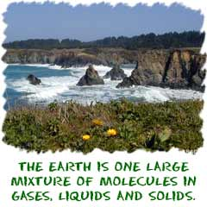
Matter is everything around you. Matter is anything made of atoms and molecules. Matter is anything that has mass and takes up space. If you are new to the idea of mass, it is the amount of stuff in an object. We talk about the difference between mass and weight in another section. Matter is sometimes related to light and electromagnetic radiation. Even though matter can be found all over the Universe, you only find it in a few forms. As of 1995, scientists have identified five physical states of matter. Each of those states is sometimes called a phase. They may even discover one more state by the time you get old.

Five States of Matter
You should know about solids, liquids, gases, plasmas, and one state called the Bose-Einstein condensate (BEC). Scientists have always known about solids, liquids, and gases. Plasma was a new idea when it was noticed by William Crookes in 1879. The scientists who worked with the Bose-Einstein condensate received a Nobel Prize for their work in 1995. But what makes a state of matter? It's about the physical state of the molecules and atoms. Think about solids. They are often hard and brittle. Liquids are all fluidy at room temperature. Gases are there, but you usually smell them before you can see them. You don't see them because their molecules are really far apart. The BEC is all about molecules that are really close to each other (even closer than atoms in a solid).
Changing States of Matter
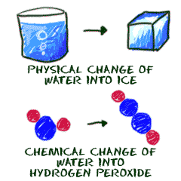
Elements and compounds can move from one physical state to another and not change their basic atomic parts. Oxygen (O₂) as a gas still has the same properties as liquid oxygen. The liquid state is colder and denser, but the molecules (the basic parts) are still the same. Water (H₂O) is another example. A water molecule is made up of two hydrogen (H) atoms and one oxygen (O) atom. It has the same molecular structure whether it is a gas, liquid, or solid. Although its physical state may change, its chemical state remains the same.
So you're asking, "What is a chemical change?" Let's start with a glass of pure water. If the formula of water were to change, that would be a chemical change. If you could just add a second oxygen atom, you would have hydrogen peroxide (H₂O₂). The molecules in your glass would not be water anymore. A chemical change happens when the atoms in a molecule are moved around or when atoms are added or taken away. Chemical changes happen when bonds between atoms are created or destroyed. Changing physical states of matter is about changing densities, pressures, temperatures, and other physical properties. The basic chemical structure does not change when there is a physical change.

Atoms Around Us
Atoms are building blocks. If you want to create a language, you'll need an alphabet. If you want to build proteins, you will need amino acids. If you want to build molecules, you will need atoms of different elements. Each element is a little bit different from the rest. Those elements are the alphabet in the language of molecules.
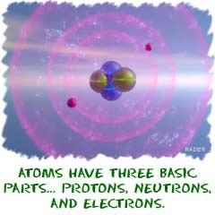
Why are we talking about elements? This is the section on atoms. Atoms are the general term used to describe pieces of matter. You are made up of billions and billions of atoms. However, you may only find about 40 elements inside of your body. You would find hydrogen (H) atoms, oxygen(O) atoms, and a bunch of others. Those other atoms are made of the same basic pieces, but they are organized in different ways to make each element unique.
Common Elements
Let's work with that idea for a bit. If you read a book, you will find a bunch of words on a page. Letters make up those words. In English, we only have twenty-six letters, but we can make thousands of words. In chemistry, you are working with around 120 elements, and when you combine them you can make millions of molecules. Molecules are groups of atoms bonded together in the same way that words are groups of letters. An "A" will always be an "A" no matter what word it is in. A sodium (Na) atom will always be a sodium atom no matter what compound it is in. While the atoms may have different masses and organization, they are all built with the same parts. Electrons, protons, and neutrons make the Universe the way it is.
If you want to do a little more thinking, start with the smallest particles of matter. Those super-tiny subatomic particles are used to create atoms. Atoms are used to create the molecules around us. As we just learned, there are almost 120 known types of atoms. That means there are almost 120 elements that can be found in the molecules we know. Smaller molecules can work together and build macromolecules. It just goes on. Everything you see is built from something else.
You could start really small...
- Particles of matter - Planetary Systems with Stars
- Atoms - Galaxies
- Molecules - The Universe
- Macromolecules ...And finish really big.
- Cell organelles
- Cells
- Tissues
- Organs
- Systems
- Organisms
- Populations
- Ecosystems
- Biospheres
- Planets

Periodic Table and the Element
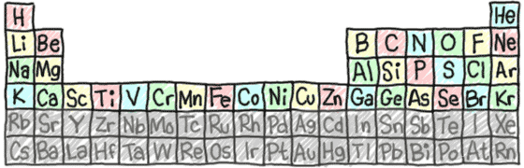
Now we're getting to the heart and soul of the way your universe works. Elements are the building blocks for all matter. We talked about quarks in the atoms section. They are smaller than the main components of an element such as electrons, protons, and neutrons. Only when those parts come together do we have atoms with recognizable traits. Some subatomic particles combine to make an oxygen (O) atom. Others can combine to form a nitrogen (N) atom. It's the elements that are different and unique, even though they are made of the same pieces.
We sometimes use the terms atom and element to mean the same thing. Remember that atom is the general term. Everything is made of atoms. The term element is used to describe atoms with specific characteristics. There are about 120 different elements. You are made up of billions and billions of atoms but you probably won't find more than 40 elements (types of atoms) in your body. Chemists have figured out that over 95% of your body is made up of hydrogen (H), carbon (C), nitrogen (N), oxygen (O), phosphorus (P), sulfur (S), and calcium (Ca).

The Same Everywhere
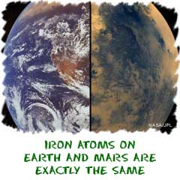
As far as we know, there are only so many basic elements. Up to this point in time, we have discovered/created over 120. While there may be more out there to discover, the basic elements remain the same. Iron (Fe) atoms found on Earth are identical to iron atoms found on meteorites. The iron atoms on Mars that make the soil red are the same too.
With the tools you learn here, you can explore and understand the Universe. You will never stop discovering new reactions and compounds, but the elements will remain the same.

Browsing Biochemistry
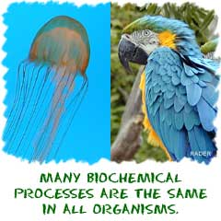
If you have visited our biology sections, you may recognize some of the ideas here. We felt it was more appropriate to have the biochemistry section located here in our chemistry pages. It is one of the crossover fields of chemistry. Biochemists have to understand both the living world and the chemical world to be the best at their jobs. Even if you didn't want to become a biochemist, you'll still have to know the details of how atoms move if you wanted to be a biologist.
The key thing to remember is that biochemistry is the chemistry of the living world. Plants, animals, single-celled organisms... they all use the same basic chemical compounds to live their lives. Biochemistry is not about the cells or the organisms. It's about the smallest parts of those organisms, the molecules. It's also about the cycles that happen to create those biological compounds. The cycles usually rely on enzymes and other proteins to move atoms and molecules.
You can guess from the name that biochemical cycles repeat over and over. They are the things that allow living creatures to survive on Earth. It could be the constant process of photosynthesis that creates sugars in plants, or the building of complex proteins in the cells of your body. Every cycle has a place, and they are just one small piece that helps an organism survive. In each of those cycles, molecules are needed (as reactants) and changed into products. It's one big network of activity where each piece relies on all of the others. A compound, such as an herbicide, may only break one part of one cycle in a plant. However, because everything needs to work together, the whole plant eventually dies.
Biochemistry is the study of the chemistry that takes place in living organisms, especially the structure and function of their chemical components, such as proteins, carbohydrates, lipids, nucleic acids, and small molecules present in cells. Biochemistry could also (now) be defined as being the chemistry of enzyme-mediated reactions, whether in vivo or in the test tube, with natural or artificially modified enzymes and other chemicals.
Categories
Biochemistry is principally concerned with the chemistry of substances that can be classified into a few major categories:
- Carbohydrates
- Lipids
- Proteins and Amino acids
- Nucleic acids
The bulk of biochemical investigation focuses on the properties of proteins, many of which are enzymes. For historical reasons, the biochemistry of metabolism has been one of the most extensively described aspects of the cell. Important modern-day areas include the genetic code (DNA, RNA),protein synthesis, cell membrane transport and energy decomposition cycles]

Chemical Reactions
Let's start with the idea of a reaction. In chemistry, a reaction happens when two or more molecules interact and the molecules change. That's it. What molecules are they? How do they interact? What happens? The possibilities are infinite. When you are trying to understand reactions, imagine that you are working with the atoms. Imagine the building blocks are right in front of you on the table, instead of billions of reactions in your beaker. Sometimes we do this using our chemistry toys to help us visualize the movement of the atoms. There are a few key points you should know about chemical reactions:
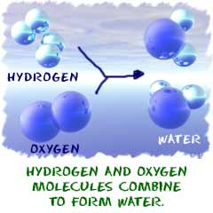
1. A chemical change must occur. You start with one compound and turn it into another. That's an example of a chemical change. A steel garbage can rusting is a chemical reaction. That rusting happens because the iron (Fe) in the metal combines with oxygen (O₂) in the atmosphere. When a refrigerator or air conditioner cools the air, there is no reaction between the air molecules. The change in temperature is a physical change. When you melt an ice cube, it is a physical change. When you put bleach in the washing machine to clean your clothes, a chemical change breaks up your stains.
2. A reaction could include ions, compounds, or molecules of a single element. We said molecules in the previous paragraph, but a reaction can happen with anything, just as long as a chemical change occurs (not a physical one). If you put pure hydrogen gas(H₂) and pure oxygen gas in a room, they can be involved in a reaction. The slow rate of reaction will have the atoms bonding to form water (H₂O) very slowly. If you were to add a spark, those gases would create a reaction that would result in a huge explosion. Chemists’ call that spark a catalyst.
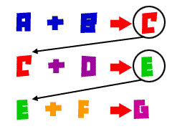
3. Single reactions often happen as part of a larger series of reactions. Take something as simple as moving your arm. The contraction of that muscle requires sugars for energy. Those sugars need to be metabolized. You'll find that proteins need to move in a certain way to make the muscle contract. A whole series (hundreds) of different reactions are needed to make that simple movement happen. In the case of your arm, some are physical changes and some are chemical. In the process of making sugars in a plant, you might have as many as a dozen chemical changes to get through the Calvin cycle which makes glucose (C₆H₁₂O₆) molecules.

