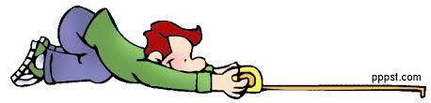 Metric Measurement Lab - Biology
Instructions: For this lab, you will visit several different stations to measure items using various lab equipment.
Graduated cylinders – what volume of liquid is in each one?
What metric units are you using at this station? _______________

A. _________________ B. _________________ C. _________________

Meter Sticks – measure the lengths of each object using a meter stick or ruler.
What metric units are you using at this station? _______________

A. Length of concrete block _________________

B. height of our classroom door _________________

C. length of the Bulletin Board _____________________

D. length of lab table top ________________ E. width of lab table top ________________
What is the area of the lab table’s top? __________________
What additional measurement would you need in order to find its volume? ____________________

Triple Beam Balance – measure the mass of each cube.
What metric units are you using at this station? ________________

A. _________________ B. _________________

Water displacement – use your water displacement skills to find the volume of the??? USE UNITS!!
Volume of water before adding object: _________________
Volume of water after adding object: __________________

Volume of object: _______________________

