Biology Spring Final Review Name:

Section 1: DNA
1. The genetic material in the cell is ___________. Where is it located in the cell? _________________.

2. The components which make up DNA are called _________________.

3. What are the three components of a nucleotide?

4. What are the four bases in DNA? How do the bases pair together?

5. How do RNA and DNA differ?

Section 2: DNA Replication
6. What are the steps in DNA replication?

7. What would the complementary strand for the following DNA strand be?
original strand A C C G T C A A C T A G
Section 3: Protein Synthesis:
8. What is a triplet? How many triplets are in the original DNA strand above?

9. Each DNA triplet eventually codes for one ____________ _________ (part of a protein).
10. In protein synthesis, what is the job of:
messenger RNA:

transfer RNA:

11. What is a codon? What is an anticodon?

12. The two phases of protein synthesis are ______________ and ______________.

13. Use the amino acid chart in your notes to help you fill out the chart below.
DNA triplet | mRNA codon | tRNA anti codon | amino acid
 |  | AAA
GTC
 |  |  | Methionine
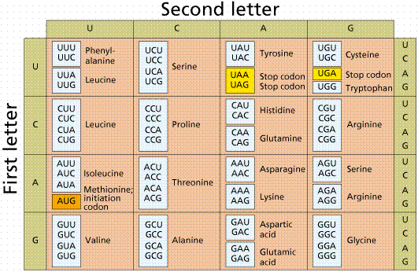

Mitosis/Meiosis
14) Which of the following is the correct order of the cell cycle?
- prophase, anaphase, metaphase, telophase, interphase
- metaphase, anaphase, interphase, prophase, telophase
- interphase, prophase, metaphase, anaphase, telophase
- telophase, prophase, metaphase, anaphase, interphase

Match the cell cycle phases with the correct description.

15. _______ Interphase a) chromosomes line up along the middle of the cell

16. _______ Telophase b) the cell divides into two identical cells

17. _______ Prophase c) resting stage between divisions, DNA replicated

18. _______ Anaphase d) replicated chromosomes (chromatids) pair together

19. _______ Metaphase e) chromosomes move away from each other to opposite sides of the cell
Extra Credit: The splitting of the cell membrane is called _____________________.
Phase:
Phase:
Phase:
Phase:
Phase:

20. Label the diagrams below with the name of the correct phase.

Meiosis

_____ 21. If a parent cell containing 46 chromosomes went through meiosis, which of the following would be produced?
a) 4 daughter cells each with 46 chromosomes
b) 4 daughter cells each with 23 chromosomes
c) 2 daughter cells each with 46 chromosomes
d) 2 daughter cells each with 23 chromosomes

_____ 22. All of the following are DIFFERENT between mitosis and meiosis EXCEPT _______.
a) number of cell divisions
b) phase in which the DNA is replicated
c) number of chromosomes present in each daughter cell
d) number of daughter cells produced

_____ 23. Meiosis increases genetic variablility in a population through _____.
a) independent assortment c) interference
b) crossing over d) both a and b
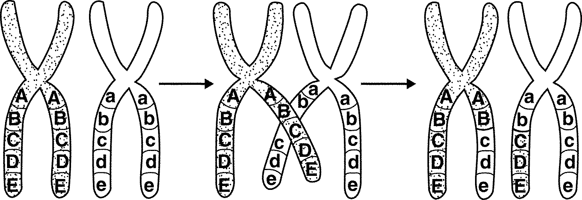
_____ 24. What process is shown in the figure?
a) independent assortment c) interference
b) crossing over d) both a and b

Genetics

25. Define the following:

a. Genetics

c. True-breeding

d. Trait

e. Hybrid

f. Gene

g. Allele

i. Gamete

j. Probability

k. Homozygous

l. Heterozygous

m. Phenotype

n. Genotype

p. Complete dominance

q. Incomplete dominance

r. Codominance

26. The patterns of inheritance were discovered by a monk named ____________________ who studied pea plants.

27. What were his reasons for choosing that type of plant?
28. In body cells, each individual carries ______ alleles for each gene. One allele is inherited from the mother and one from the ____________________.

29. A red flower and white flower are mated and all the offspring are red. This is an example of which type of dominance?

30. A tall flower and a short flower are mated and all the offspring are medium height. This is an example of which type of dominance?

31. A black dog and white dog are mated and all the offspring are black and white. This is an example of which type of dominance?

32. Use the following information to answer the questions below:
Pea color: G = green g = yellow

a. The homozygous dominant genotype is _______, the homozygous recessive genotype is _______, and the heterozygous genotype is _______.

b. Cross a heterozygous green pea with a yellow pea.
Parental genotypes ___________________
Show the Punnett square

Offspring genotypic ratio __________________________

Offspring phenotypic ratio _________________________
What is the probability that an offspring from this cross will have the genotype Gg? ________

c. Cross a heterozygous green pea with a heterozygous green pea.
Parental genotypes _______________________
Show the Punnett square

Offspring genotypic ratio _______________________________

Offspring phenotypic ratio ______________________________
What is the probability that an offspring from this cross will have the genotype gg? _______

Evolution Review
33.What specifically was Charles Darwin’s contribution to Science?

34.What patterns did Darwin observe among organisms of the Galapagos Islands?

35.List the four main ideas of Darwin’s Theory.

36.What are fossils?

37.How did Darwin explain the differences in shell shape of tortoises from the Hood Island and Isabela Island?

38.Compare Natural Selection and Artificial Selection.

39.Define Fitness, adaptation,

40. What does struggle for existence mean?

41 .List the three areas where evidence for evolution can be found.

42. Why are homologous structures so important to evolutionists? (what do they indicate?, what are they?)

43.What is population?

44.Why is genetic variation so important to survival? (gene pool)

45.How can changes in allele frequency occur?

46.What is a bottle neck?

47.Explain-genetic drift, founder effect, gene flow

48.Describe the types of natural selection: Directional, stabilizing, and disruptive.

Taxonomy

49. Put the seven levels of classification in order.
phylum, order, species, kingdom, class, family, genus

___________, _________, _________, ____________, ____________, __________, ________

50. Dogs (Canis familiaris) are most closely related genetically to which of the following organisms?
a) African hunting dog (Lycaon pictus)
b) Gray wolf (Canis lupus)
c) Grizzly bear (Ursus arctos)
d) Domestic cat (Felis catus)

51. Organisms that do not have a membrane bound nucleus are _______.
a) prokaryotic c) eukaryotic
b) archebacteria or eubacteria d) both a and b

52. Which of the following kingdom’s members DO NOT have cell walls?
a) fungi c) animalia
b) plantae d) both a and b
53. _____________ shows the evolutionary relationships between organisms
a) phylogenetic tree c) dichotomous tree
b) geologic tree d) fossil record

54. Which of the following are ways to classify organisms?
a) structure c) fossil record
b) DNA sequencing d) all of the above

55. T/F Taxonomy is a fixed science and will never change

56. Use the classification key below to identify the insect shown.
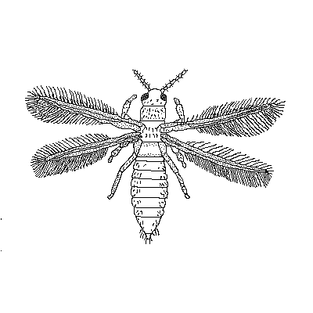
1a. has wings ... go to 2
10. _______________
1b. does not have wings .... go to 7
2a wings lay flat over body ... go to 3
2b. wings do not lay flat over body ... go to 4
3a. wings overlap ... Megaloptera (alderfly)
3b. wings touch but do not overlap ... Homoptera
4a. wings stick out to the side ... go to 5
4b wings stick out towards the back ... go to 6
5a. two wings visible ... Neuroptera
5b. four wings visible ... Thysanoptera (winged thrips)
6a. four wings visible ... Megaloptera (dobsonfly)
6b. two wings visible .... Raphidioptera
7a. Long pointed body ... Thysanoptera ( wingless thrip)
7b. Rounded body ... Coleoptera

Bacteria/Viruses
57. The object below is a ________________.

58. Label parts A, B, C, and D. 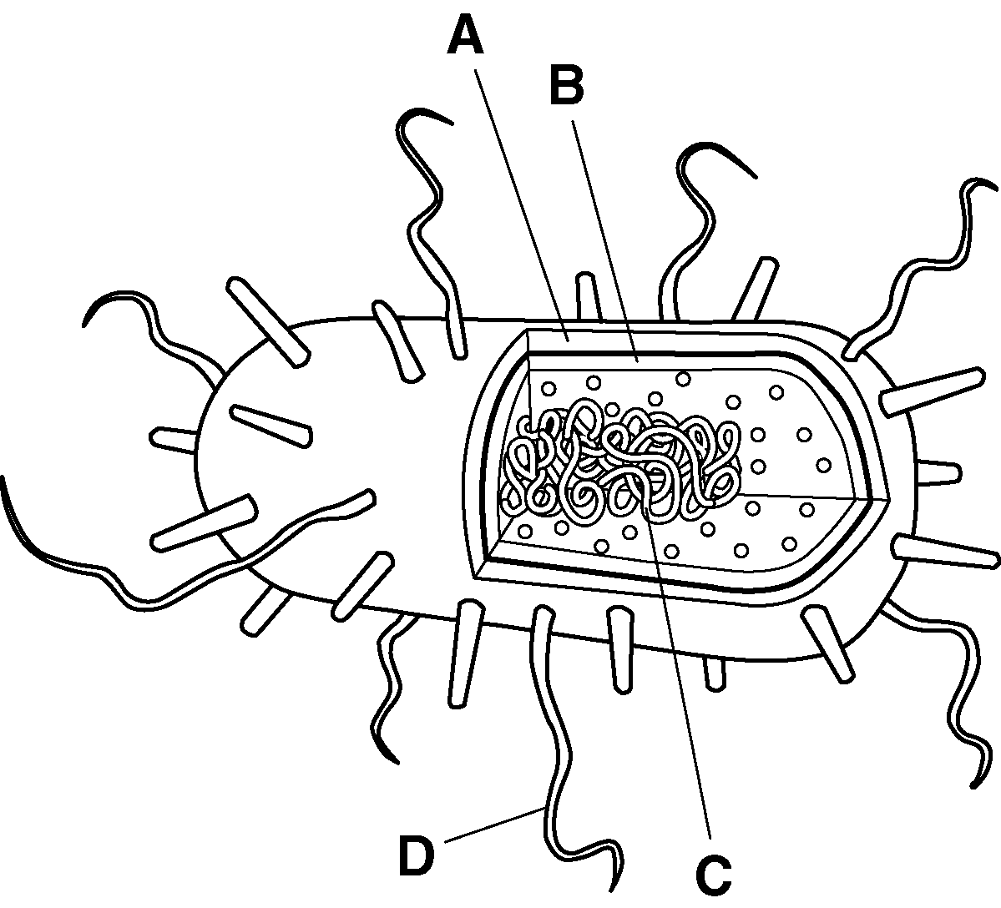
59. What is a host?

60.How do viruses reproduce?

61. The process by which the viruses burst out of the cell is called _____________.

62. What is a pathogen?

63.. What do antibiotics do?

64. What is a vaccine?

Plants

65. Define xylem and phloem.

VI Leaves
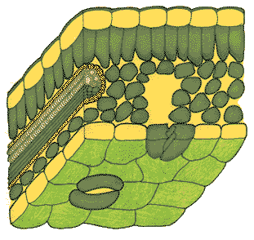
66. Explain the function of these parts of the leaf:
epidermis –

cuticle -

stomata -

guard cells –

mesophyll –

leaf veins –

67. Label the leaf diagram

III. Flowers
68. The female part of the flower is called the ______________________

69. Describe the function of each of the following parts of the pistil.
- 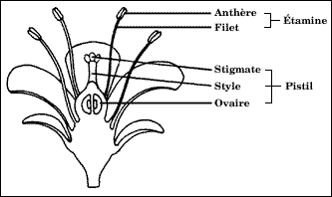Stigma-

- Style-

- Ovary-

70. The male part of the flower is called the _____________

71. Label the flower diagram

72. Describe the function of the two parts of the stamen.
- anther

b) filament

