The Structure of DNA
Lesson Objectives
 Identify the chemical components of DNA.
Discuss the experiments leading to the identification of DNA as the molecule that carries the genetic code.
Describe the steps leading to the development of the double-helix model of DNA.
Lesson Summary
The Components of DNA DNA is a nucleic acid made up of nucleotides joined into long strands or chains by covalent bonds. Nucleotides may be joined in any order.
A DNA nucleotide is a unit made of a nitrogenous base, a 5-carbon sugar called deoxyribose, and a phosphate group.
DNA has four kinds of nitrogenous bases: adenine, guanine, cytosine, and thymine.
Solving the Structure of DNA
Erwin Chargaff showed that the percentages of adenine and thymine are almost always equal in DNA. The percentages of guanine and cytosine are also almost equal.
Rosalind Franklin’s X-ray diffraction studies revealed the double-helix structure of DNA.
James Watson and Francis Crick built a model that explained the structure of DNA.
The Double-Helix Model The double-helix model explains Chargaff ’s rule of base pairing and how the two strands of DNA are held together. The model showed the following:
The two strands in the double helix run in opposite directions, with the nitrogenous
bases in the center.
Each strand carries a sequence of nucleotides, arranged almost like the letters in a four letter alphabet for recording genetic information.
Hydrogen bonds hold the strands together. The bonds are easily broken allowing DNA strands to separate.
Hydrogen bonds form only between certain base pairs—adenine with thymine, and cytosine with guanine. This is called base pairing.
The Components of DNA
For Questions 1–5, complete each statement by writing in the correct word or words.
1. The building blocks of DNA are _________________.
2. Nucleotides in DNA are made of three basic components: a sugar called _________________, a _________________, and a nitrogenous _________________.
3. DNA contains four kinds of nitrogenous bases: _________________, _________________, _________________, and _________________.
4. In DNA, _________________ can be joined in any order.
5. The nucleotides in DNA are joined by _________________ bonds.
Solving the Structure of DNA
6. Complete the table to describe each scientist’s contribution to solving the structure of DNA.
Scientist | Contribution
Erwin Chargaff
Rosalind Franklin
James Watson and Francis Crick

7. Complete the table by estimating the percentages of each based on Chargaff’s rules.
DNA sample | Percent of  adenine | Percent of  thymine | Percent of  guanine | Percent of  cytosine
1 | 31.5 |  | 18.5
2 |  | 30 | 20
3 |  | 33 |  | 17

The Double-Helix Model
For Questions 8–13, on the lines provided, label the parts of the DNA molecule that correspond to the numbers in the diagram.
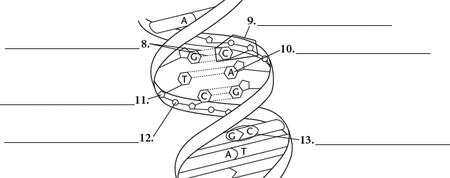
14. The drawing below shows half of a DNA molecule. Fill in the appropriate letters for the other half. Explain why you drew your sketch the way you did.
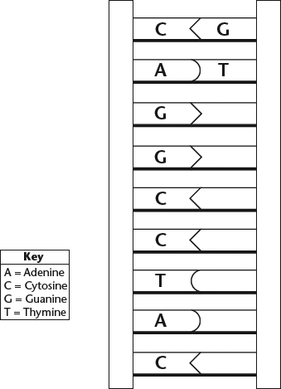

15. Complete this table to show how the structure of the DNA molecule allows it to perform each essential function.
Function | Structure of the Molecule
Store information
Copy information
Transmit information

