The Biosphere
What Is Ecology?
Lesson Objectives
 Describe the study of ecology.
Explain how biotic and abiotic factors influence an ecosystem.
Describe the methods used to study ecology.
Lesson Summary
Investigating Our Living Planet Ecology is the scientific study of interactions among organisms and between organisms and their environment. Earth’s organisms live in the biosphere. All life on Earth and all parts of the Earth in which life exists, including land, water, and the atmosphere make up the biosphere. Ecologists may study different levels of ecological organization:
Individual organism
An assemblage of individuals that belong to the same species and live in the same area is called a population.
An assemblage of different populations that live together in an area is referred to as a community.
An ecosystem includes all the organisms that live in a particular place, together with their physical environment.
A group of ecosystems that have similar climates and organisms is called a biome.
Biotic and Abiotic Factors Ecosystems include biotic and abiotic factors.
A biotic factor is any living part of an environment.
An abiotic factor is any nonliving part of an environment.
Ecological Methods Ecologists use three basic methods of research: observation, experimentation, and modeling:
Observation often leads to questions and hypotheses.
Experiments can be used to test hypotheses.
Modeling helps ecologists understand complex processes.
Investigating Our Living Planet
1. What is ecology?

2. What does the biosphere contain?

3. How are human economics and ecology linked?

Use the diagram to answer Questions 4–5.
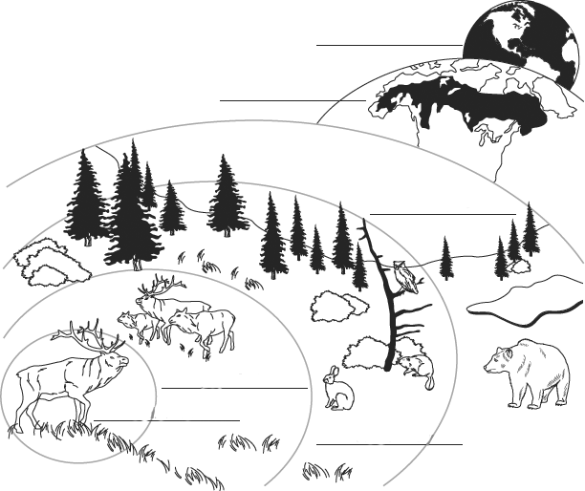
4. Label each level of organization on the diagram.
5. Explain the relationship between ecosystems and biomes.

Biotic and Abiotic Factors
In an ecosystem, biotic factors are biological influences on organisms. Abiotic factors are nonliving (or physical) influences on organisms.
Circle each abiotic factor. Draw an X over each biotic factor.
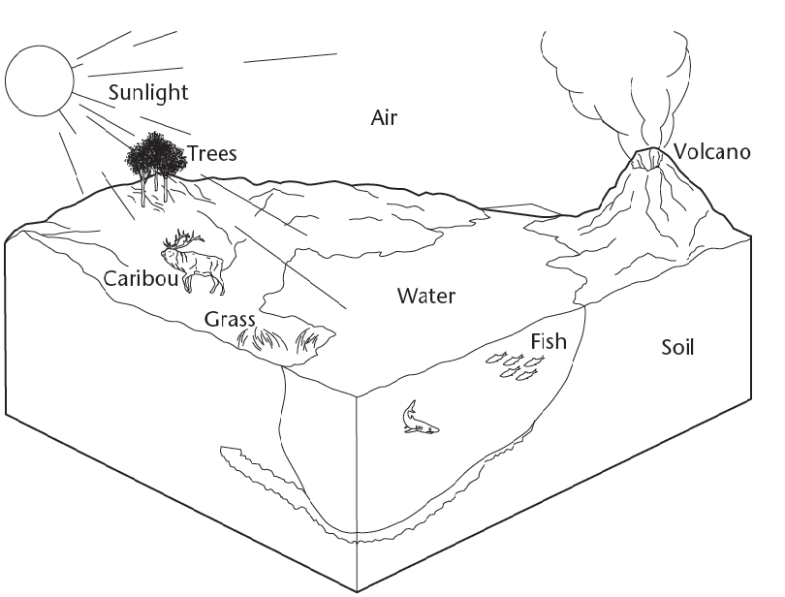

Use the illustration to answer the questions.
6. Are factors related to climate, such as rainfall and temperature, biotic or abiotic factors?

Ecological Methods
7. Why might an ecologist set up an artificial environment in a laboratory?

8. Why are many ecological phenomena difficult to study?

9. Why do ecologists make models?

